
المملكة العربية السعودية الصف: الخامس الابتدائي
وزارة التعليم الفترة الدراسية: الثانية
المدرسة الابتدائية ............. العام الدراسي 1447 هـ
الزمن: ساعتان
الاختبار النهائي لمادة اللغة الإنجليزية – الصف الخامس الابتدائي – الفترة الدراسية الثانية (الدور الأول) لعام 1447 هـ
عزيزتي الطالبة:
- استعيني بالله ثم اجيبي عن الأسئلة
- فضلا تأكدي من كتابة اسمك الرباعي ورقم الجلوس
- الإجابة باللون الأزرق فقط

اسم الطالبة رباعيا
رقم الجلوس: |  | الصف: الخامس الابتدائي | المادة: اللغة الإنجليزية
اليوم: | التاريخ: / 1 / 1448 هـ

المدققة وتوقيعها | المراجعة وتوقيعها | المصححة وتوقيعها | الدرجة كتابة | الدرجة رقما | السؤال
 |  |  | فقط |  | General  Questions
 |  |  | فقط |  | Guided  Composition
 |  |  | فقط |  | Reading  Short Sentence
 |  |  | فقط |  | Grammar
 |  |  | فقط |  | Vocabulary
 |  |  | فقط |  | Orthography
 |  |  | فقط | 40 | المجموع


Kingdom of Saudi Arabia 5th Elementary Grade
Ministry of Education Time: Two Hours
………..Elementary School Number of papers: 3 . Final Exam – Second Term – 1447 AH
- General Questions:
/ 7
  - Match the questions with the correct answers:
A |  | B
1. What were you doing at 6 o’clock? |  | I need fishing rod for fishing.
2. What items do you need for fishing? |  | I have used a car and a bus.
3. Have you bought a new umbrella? |  | I was sleeping.
4. What kind of transportation have you used? |  | No, I haven’t.

  - Choose the correct answer:
1- What are the people in stories called?
a- places | b- characters
2- Did you have fun on your trip?
a- Yes, I was. | b- Yes, I did.
3- What do kings and queens wear that is made of gold?
a- belt | b- crown
/ 7
- Guided Composition:
  - Complete the paragraph about Your Last Outdoor Activity. Use the words from the box.
felt – camping – clothes – weekend – cooked – tent – took
My Last Outdoor Activity
Last ……………, I went ……………with my family. We put up a …………… and …………… food outside. I …………… a flashlight and warm …………… with me. It was fun and I …………… happy.

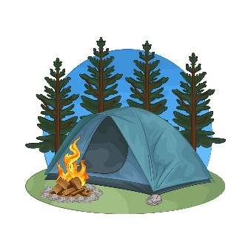

- Reading Short Sentences:
/ 7
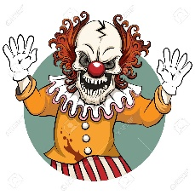

  - Read the sentences then match them with the correct pictures:
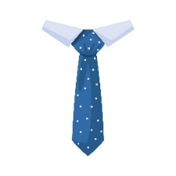 | 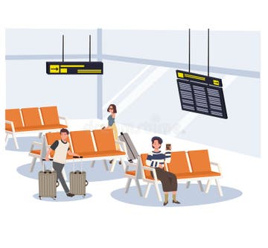 |  | 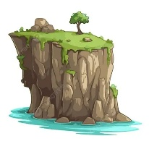
a- It’s a spotted tie.  b- It’s a striped tie. | a-_It is a platform.  b-_It is a terminal. | a-_The plane lands.  b-_The plane takes off. | a-_That is a cliff.  b-_That is a forest. | a-_It is a cartoon.  b-_It is a horror story.

  - Read the passage and answer the questions below.
Little Red Riding Hood
Little Red Riding Hood had a basket of food for her sick grandma. She walked through the forest and met a big, hungry wolf. The wolf ran to Grandma’s house and tried to eat her. A kind woodcutter came and saved both Little Red Riding Hood and her grandma.
- Choose the correct answer:
1.Who was Little Red Riding Hood visiting?  a- her friend.  b- her grandma.  c- her teacher. | 2. What did she carry in her basket?  a- toys  b- food  c- clothes

- Grammar:
/ 7
  - Choose the correct answer:
    - The belt (is make – is made – are made) of leather and metal.
    - We have (take – took – taken) a tour before.
    - The plane hasn’t departed (just – yet – already).
    - They didn’t (see – saw – seeing) the snake.
    - (Who – When – While) Jack was rafting, his raft hit a rock.
    - He was (watch – watched – watching) a movie.
    - How about (see – saw – seeing) a horror movie?

- Vocabulary:
/ 7
  - Write the words under the correct pictures:
rope – necklace – play – traffic – wool
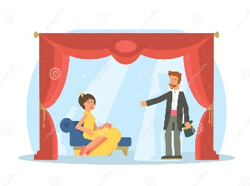
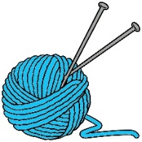 |  | 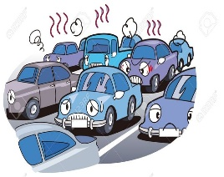 | 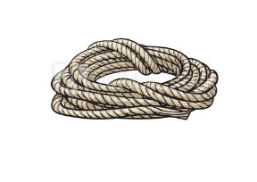

  - Fill in the blanks with the words from the box.
passport – comedy – uniform
1- You wear it at school. (………………….)
2- A document you need to travel abroad. (………………….)

- Orthography:
/ 5
  - Choose the correct missing letters:
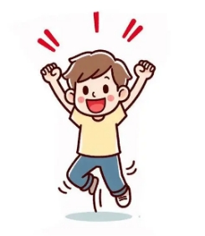  ex__ited |  | 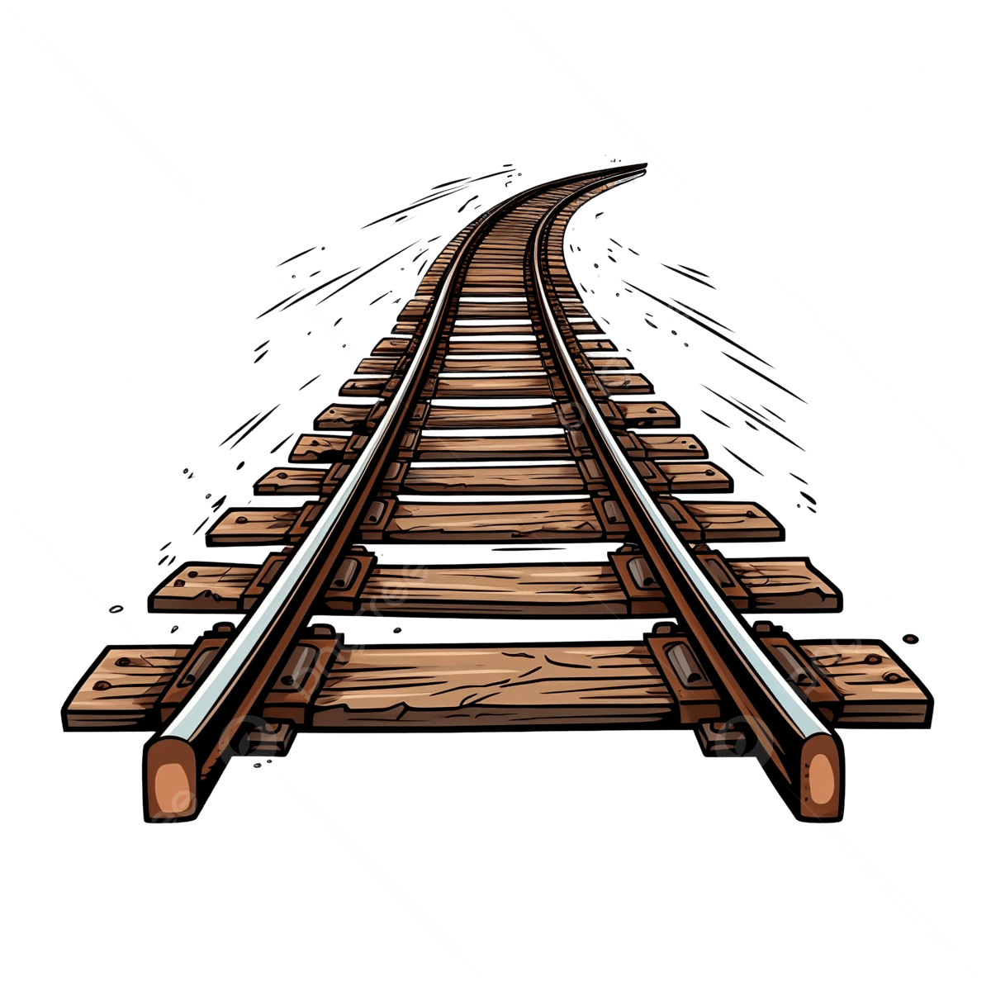  rai__road |  | 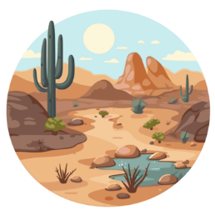  de__ert |  |   s__lk |  | 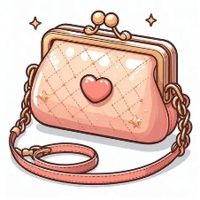  pur__e
c | s | r | l | s | z | e | i | s | c
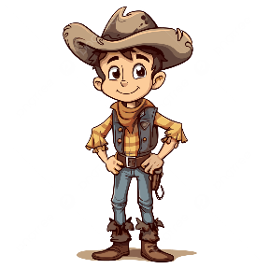  cow__oy |  |   ta__i |  | 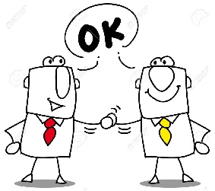  a__ree |  | 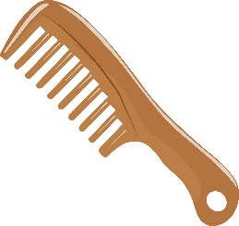  __omb |  | 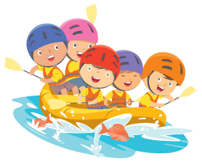  ra__ting
b | d | k | x | g | j | c | k | f | v

END OF QUESTIONS
BEST OF LUCK
Ms. Tahani AlGhamdi

