
المملكة العربية السعودية الصف: الثاني متوسط
وزارة التعليم السنة الدراسية: الثانية
المدرسة ............................... العام الدراسي 1447 هـ
الزمن: ساعتان
الاختبار النهائي لمادة اللغة الإنجليزية – الصف الثاني متوسط – السنة الدراسية الثانية (الدور الأول) لعام 1447 هـ
عزيزتي الطالبة:
- استعيني بالله ثم اجيبي عن الأسئلة
- فضلا تأكدي من كتابة اسمك الرباعي ورقم الجلوس
- الإجابة باللون الأزرق فقط

اسم الطالبة رباعيا
رقم الجلوس: |  | الصف: الثاني متوسط | المادة: اللغة الإنجليزية
اليوم: | التاريخ: / 1 / 1448 هـ

المدققة وتوقيعها | المراجعة وتوقيعها | المصححة وتوقيعها | الدرجة كتابة | الدرجة رقما | السؤال
Guided
Composition
 |  |  |  |  | Reading Comprehension
 |  |  |  |  | Grammar
 |  |  |  |  | Vocabulary
 |  |  |  |  | Orthography
 |  |  |  | 40 | المجموع

Kingdom of Saudi Arabia 2nd Intermediate Grade
Ministry of Education Time: Two Hours
………………. Intermediate School Number of papers: 3
Final Exam – Second Term - 1447 AH
- Guided Composition:

8
Use the following word bank to write a paragraph about Your Next Vacation.
Word bank: (car – climb – family – stay – travel – visit )
_________________________________
_________________________________________________________________________________________________________________________________________________________________________________________________________________________________________________________________________________________________________________________________________________________________________________________________________________________________________________________________________________________________________________________

9
- Reading Comprehension:
Read the passage and answer the questions below:
My name is Adam. I live with my family in a big house. I have two sisters and one brother. We share many chores with our parents. My brother and I take the garbage out. We also wash our father’s car twice a week. Every Friday, I weed the garden and my brother waters the plants. I also make my bed in the morning. My sister, Emily, sweeps the floor every evening and washes the dishes after dinner. She also helps Mom with shopping every Thursday. My mother cooks for us and washes our clothes. My father fixes anything broken at home.
- Choose the correct answer:
  - Adam washes his father’s car …… times in the week.
- 1 | - 2 | - 3 | - 4
  - Adam’s …………. helps him to take out the rubbish.
- brother | - sister | - uncle | - father
  - There are ……… members in Adam’s family.
- 3 | - 4 | - 5 | - 6
  - Adam weeds the garden on ……………..
- Sunday | - Tuesday | - Thursday | - Friday
  - Emily washes the dishes after …………..
- breakfast | - lunch | - dinner | - school
  - She in line 5 refers to Adam’s ………….
a- sister | b- aunt | c- grandmother | d- cousin

- Check ( T ) or ( F ):
- Adam has one sister and two brothers. ( )
- Emily helps her mom with shopping every Monday. ( )
- Adam’s father cooks for the family every day. ( )

9
- Grammar:
- Choose the correct answer:
- Let’s ………… football.
- play | - plays | - played | - playing
- This house is …………..
- they | - them | - their | - theirs
- He put ………….. salt that we couldn’t eat it.
- so | - so many | - so much | - many
- Mona is a good cook. She cooks ………….
- good | - better | - best | - well
- …………….. colour do you prefer? Red or blue?
- How | - Which | - Who | - Where
- If you study hard, you ………… your exam.
- passed | - passes | - passing | - will pass
- The mother wants her children …………. the toys away.
- put | - puts | - to put | - putting
- I wasn’t able to ………… in the dark.
- seeing | - see | - sees | - saw
- The students ……………. a test last week.
- write | - are writing | - wrote | d- have written

- Vocabulary:

9
- Write the words under the pictures:
cage – scream – mosquito – oasis – napkin – hurricane

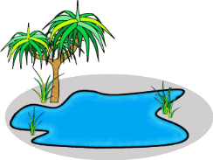
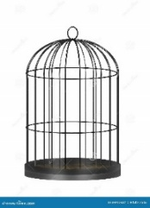
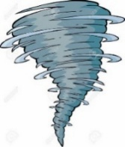
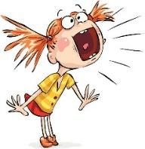
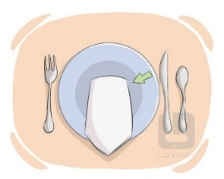

___________ ___________ ___________ ___________ ___________

- Classify the words:
babysit – fall – cheetah – earrings

Animal | Chores | Jewelery | Season

- Orthography:

5
  - Choose the correct missing letters:
- Could you lo__er your voice?
- a | - e | - o | - w
- He was sitting on a bench and listening to music through his hea__phones.
- b | - d | - p | - q
- She got st__ck in an elevator.
- a | - e | - i | - u
- Some types of ca__el have two humps and others have one.
- m | - n | - w | - f
- This game has wei__d rules.
- p | - r | - s | - t

END OF QUESTIONS
BEST OF LUCK
Ms. Tahani AlGhamdi

